Title of the Extended Abstract (To be precise and short)
Author Name1¹, Author Name2², Author Name3²
¹Some Institute of India, Mumbai, India, 400094
²Another Example Institute of Research, Address, Country, ZIP
*Corresponding author email: example_author@gmail.com

1. Introduction
Clearly state background, motivation, and objectives. Total length of extended abstract should not exceed 2 pages and should be strictly as per this document’s style, fonts etc. Use this template and modify the text as needed without disturbing the formatting. Save file as author_{track_code}.docx and submit through online abstract submission system. Below is the table indicting the track codes and corresponding conference track names.
Track code | Conference track name
Track A | Critical Materials & Circular Economy - Manufacturing, Recycling & Failure Analysis
Track B | Advanced Materials & Coatings - Processes & Characterization
Track C | Heat Treatment: Advances in Processes & Equipments

2. Materials and Methods
Describe materials, processing, and characterization techniques.
Refer any Equipment/Standard/Code/Design/Software used with details

3. Results and Discussion
Present concise results with interpretation and key findings. Always use SI units.
All figures and images in better resolution as judged by the authors for good reproducibility.
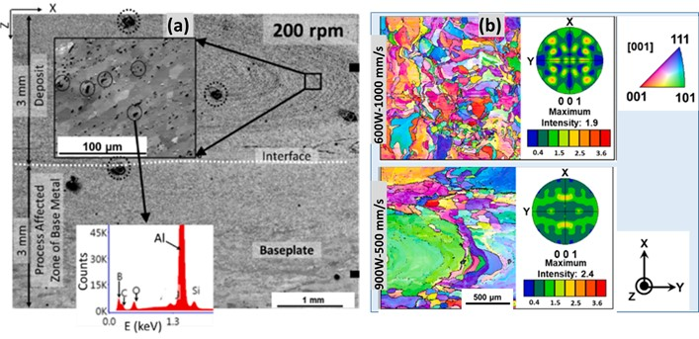
Figure 1. Include high-quality graphics with a minimum resolution of 300 dpi. A maximum of two figures is allowed. Figure captions must be in 10 pt Times New Roman. Multiple related images should be combined into a single composite figure (with labeled subfigures) rather than inserted as separate figures.

4. Conclusions / Summary
[Summarize key contributions and implications preferably as bulleted points.]

References (IEEE Style)
[1] All authors, Laser-Based Additive Manufacturing, Wiley, Place, 2022.
[2] All authors, “Laser based additive manufacturing of tungsten,” Acta Materialia, Vol. xx, pp.01-02, 2023.
[3] All authors, “Conference paper title,” Proc. Conf., Year, Place.
[4] https://www.who.int/air-pollution. [Accessed: 02-Apr-2026].

High quality passport size photograph of Presenting author

Dr. K. Arvind Rao
Department of Metallurgical and Materials Engineering
National Institute of Advanced Materials, Bengaluru, India
Brief Bio-sketch: (within 150 words)
Dr. K. Arvind Rao is a metallurgical engineer specializing in the processing and performance optimization of advanced structural materials, with a strong focus on industrial applications. His work includes the development of fabrication routes for zirconium-based alloys used in critical engineering systems. He has contributed to advancing additive manufacturing of refractory materials, particularly in process optimization and microstructure control in laser powder bed fusion (LPBF). Dr. Rao has also worked on advanced characterization using EBSD and SEM for quality control and failure analysis, and is currently exploring machine learning approaches for data-driven materials characterization. He has received several national-level recognitions for his contributions to materials technology development and has published xx papers in journals and made yy presentations in national/international conferences.

